 | CHAROTAR UNIVERSITY OF SCIENCE & TECHNOLOGY  DEVANG PATEL INSTITUTE OF ADVANCE TECHNOLOGY AND RESEARCH | 

Weekly Report
In this report students require to mention the work has been done during the week and planning for the next week. (Please fill individual report for each week)

Student ID: 18dce057 | Student Name: Shraddha Mehta
From Date:29/04/2020 | To Date:07/05/2020
Semester:4th | Internship ID: 30

Work done in last week (Attach supporting Documents):

- I have made home activity

This is initial Activity which opens everytime when we open this application.
In this Activity I have used concept of fragment to make side navigation menu .. It is also having floating point button which will lead to cart activity..

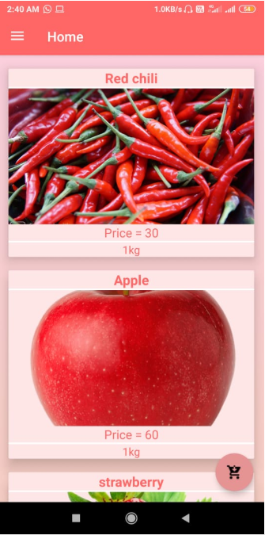 | 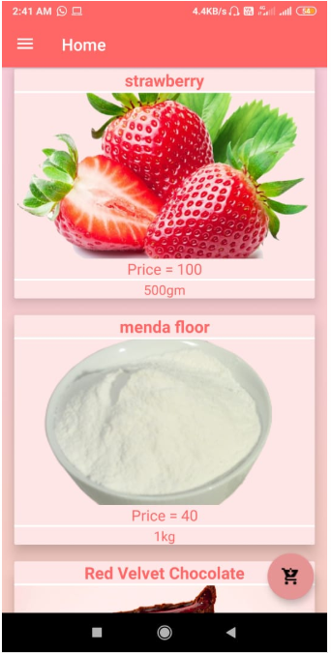
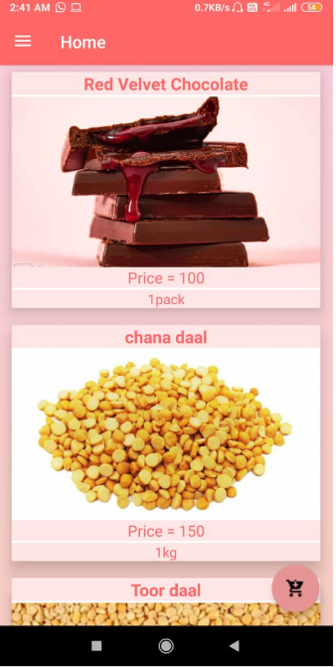 | 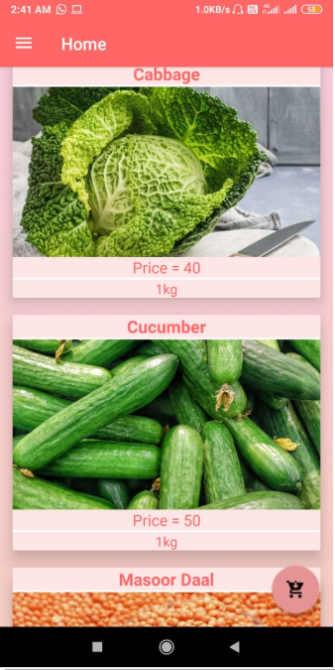

- I have made side navigation menu

Here I have created side navigation menu which includes cart, search, categories and etc. features.
Cart is lead to cart Activity , search is lead to search Activity, settings is lead to settings Activity and Logout leads to logout from an application.

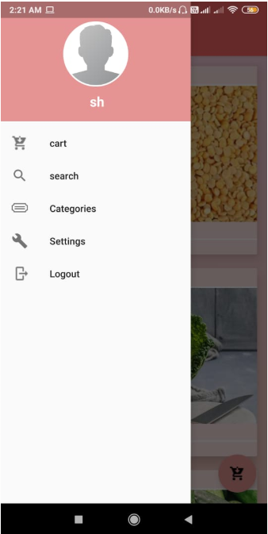

- I have made add to cart activity

This activity will open when user clicks on any items of home Activity.
It has elegant number button which is very advantageous for user..
And it also has Add to cart button after clicking add to cart button it will open home activity to select (buy ) more items.
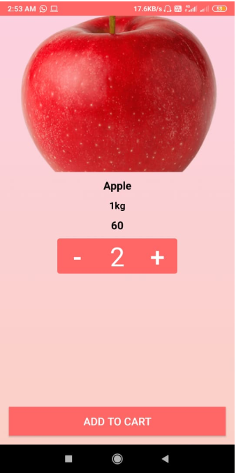 | 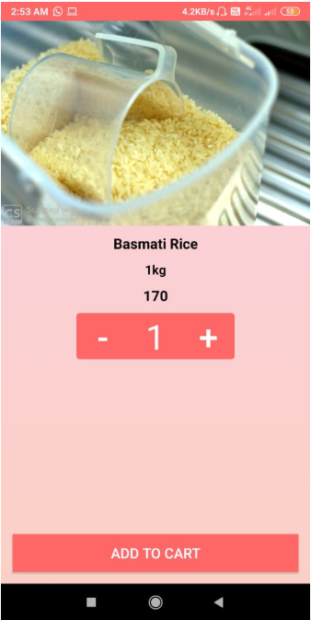

- I have made Cart activity

Cart Activity shows the total price at the top. It shows ordered items individually with their quantity and price. When we click next button it will lead to confirm final order

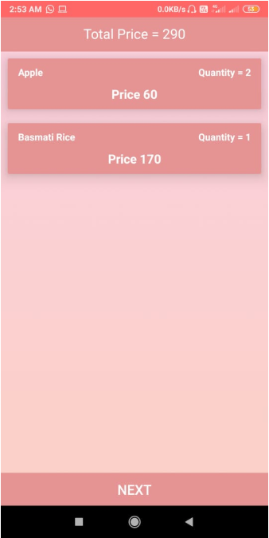

- I have made confirm final order activity

After clicking next button in cart activity this will open. It takes personal details of user for shipping order. When we click confirm then our order is confirmed at user side

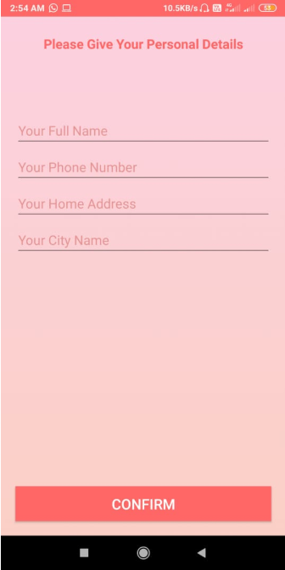 | 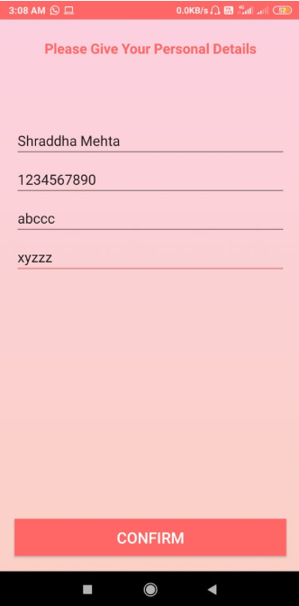

This is cart activity after placing final order. It shows shipping status weather ordered item is placed or not…
If item is shipped by an admin then user can buy new items otherwise user can not buy new items…

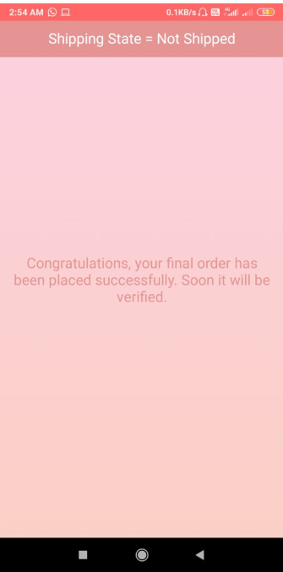

Plans for next week:

1. I will make settings Activity( profile) for user where user can set profile photo, name etc.
2. I will make security question Activity where user can set security questions which will help to recover password.
3. I will work on admin side like admin can add , remove or modifify products.

References:

https://www.vogella.com/tutorials/Firebase/article.html

https://firebase.google.com/docs/database/android/start

https://www.youtube.com/user/Firebase

https://developer.android.com/guide/navigation/navigation-form-factors

https://stackoverflow.com/questions/59404894/elegant-number-button-not-showing-in-android-studio-xml-preview

https://developer.android.com/guide/topics/ui/floating-action-button

https://developer.android.com/guide/navigation/navigation-ui

Signature of External Supervisor Signature of Internal Supervisor

